API Document
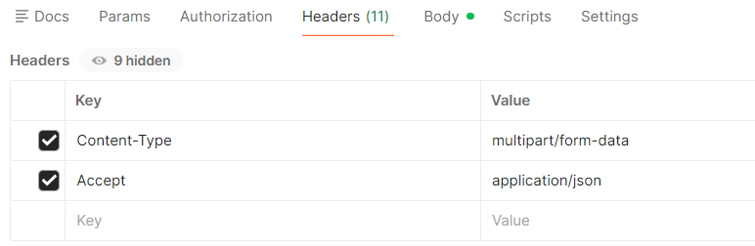
Fetch Operation
get http://127.0.0.1:8000/api/cars/
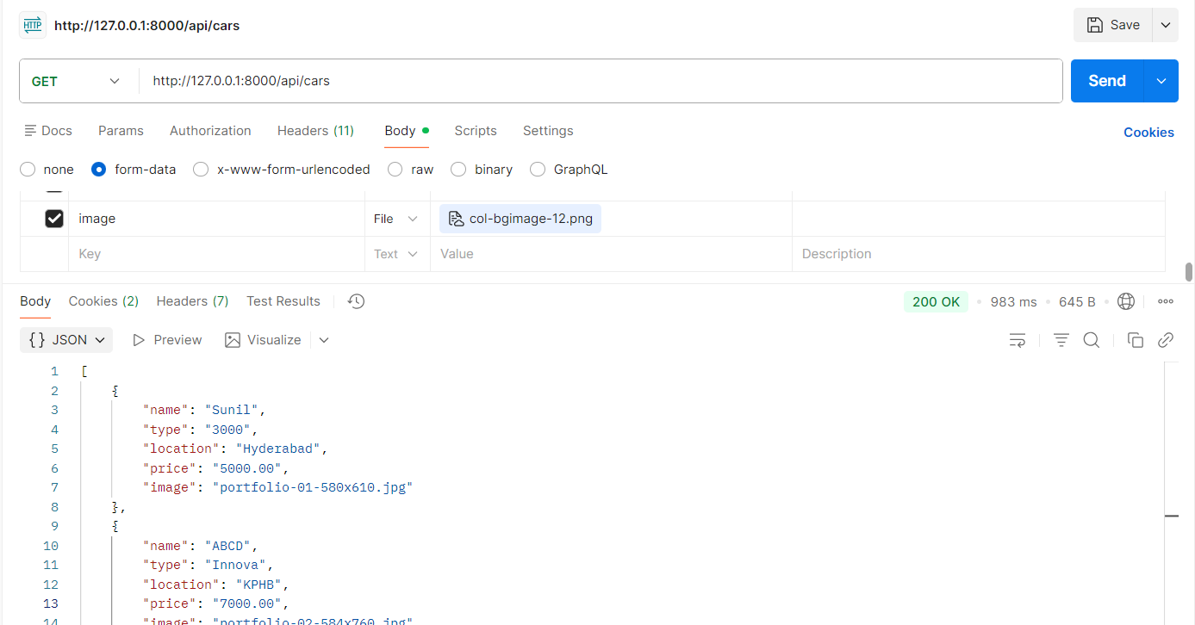
Get Operation
get http://127.0.0.1:8000/api/cars/1
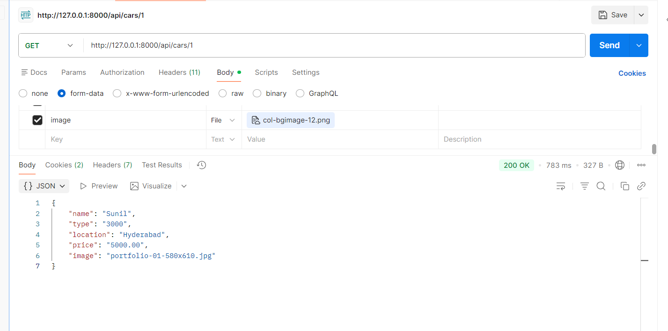
Insert Operation
Post http://127.0.0.1:8000/api/cars/
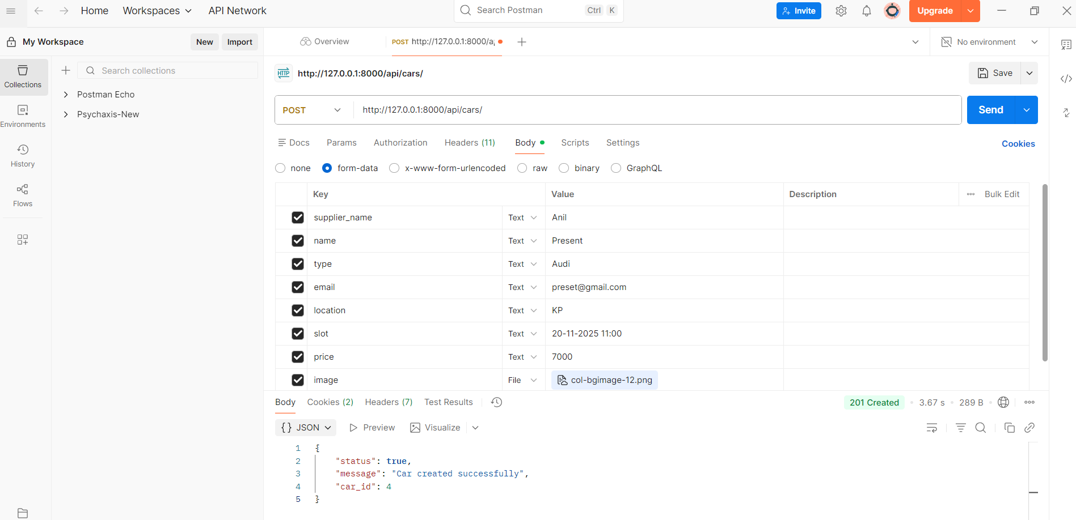
Update Operation
Post-->http://127.0.0.1:8000/api/cars/2
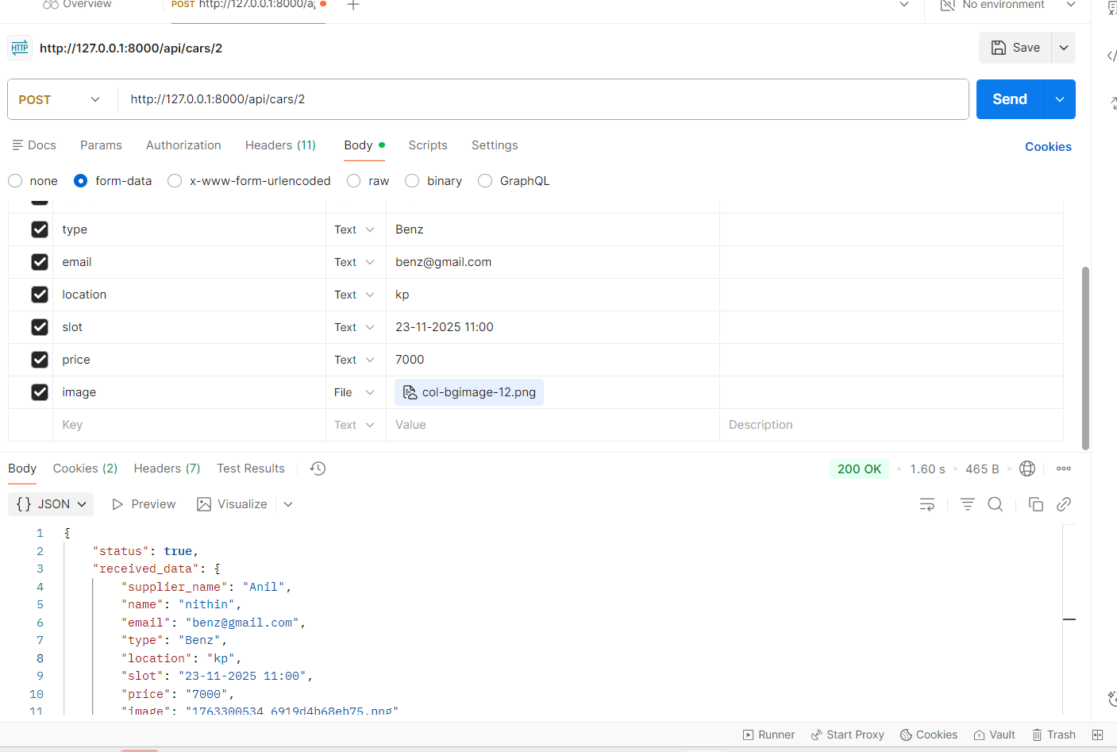

Delete Operation
delete--> http://127.0.0.1:8000/api/cars/4
